SCHOOL OF COMPUTER SCIENCE AND ARTIFICIAL INTELLIGENCE |  |  |  |  | DEPARTMENT OF COMPUTER SCIENCE ENGINEERING
ProgramName:B. Tech |  |  |  | Assignment Type: Lab |  |  | AcademicYear:2025-2026
CourseCoordinatorName |  |  |  | Venkataramana Veeramsetty
Instructor(s)Name |  |  |  | Dr. V. Venkataramana (Co-ordinator)  Dr. T. Sampath Kumar  Dr. Pramoda Patro  Dr. Brij Kishor Tiwari  Dr.J.Ravichander  Dr. Mohammand Ali Shaik  Dr. Anirodh Kumar  Mr. S.Naresh Kumar  Dr. RAJESH VELPULA  Mr. Kundhan Kumar  Ms. Ch.Rajitha  Mr. M Prakash  Mr. B.Raju  Intern 1 (Dharma teja)  Intern 2 (Sai Prasad)  Intern 3 (Sowmya)  NS_2 ( Mounika)
CourseCode |  |  | 24CS002PC215 | CourseTitle |  | AI Assisted Coding
Year/Sem |  |  | II/I | Regulation |  | R24
Date and Day  of Assignment |  |  | Week3 - Wednesday | Time(s)
Duration |  |  | 2 Hours | Applicableto  Batches
AssignmentNumber:6.3(Present assignment number)/24(Total number of assignments)
 | Q.No. | Question |  |  |  |  |  | ExpectedTime  to complete
 | 1 | Lab 6: AI-Based Code Completion – Classes, Loops, and Conditionals  Lab Objectives:  - To explore AI-powered auto-completion features for core Python constructs.  - To analyze how AI suggests logic for class definitions, loops, and conditionals.  - To evaluate the completeness and correctness of code generated by AI assistants.  Lab Outcomes (LOs):  After completing this lab, students will be able to:  - Use AI tools to generate and complete class definitions and methods.  - Understand and assess AI-suggested loops for iterative tasks.  - Generate conditional statements through prompt-driven suggestions.  - Critically evaluate AI-assisted code for correctness and clarity.  Task Description#1 (Classes)  - Use AI to complete a Student class with attributes and a method.  - Check output  - Analyze the code generated by AI tool  Instructions:  - Initialize class with attributes like name, roll no, marks  - Method to display student details  - Method to calculate grade based on marks (A:>=90, B: >=75, C: >=60, else Fail)  Start Writing code and auto complete using any AI tool  Code written without ai:  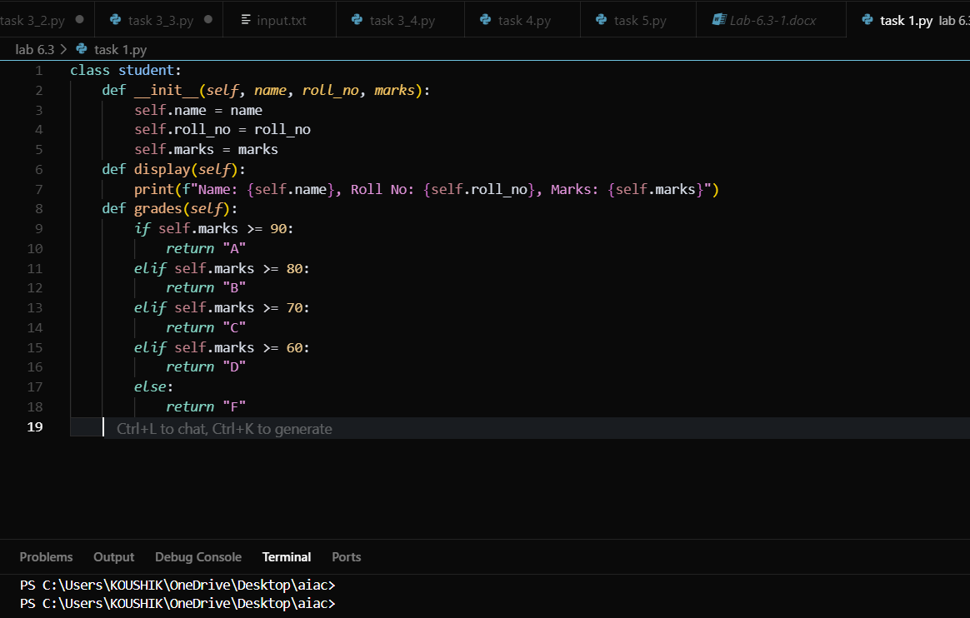  Completed code with ai:  Prompt:  Complete the code by making it take the student details Class with constructor and display_details() method. and the code should print the output and should be able to take multiple student details and also calculate the grade  Code:  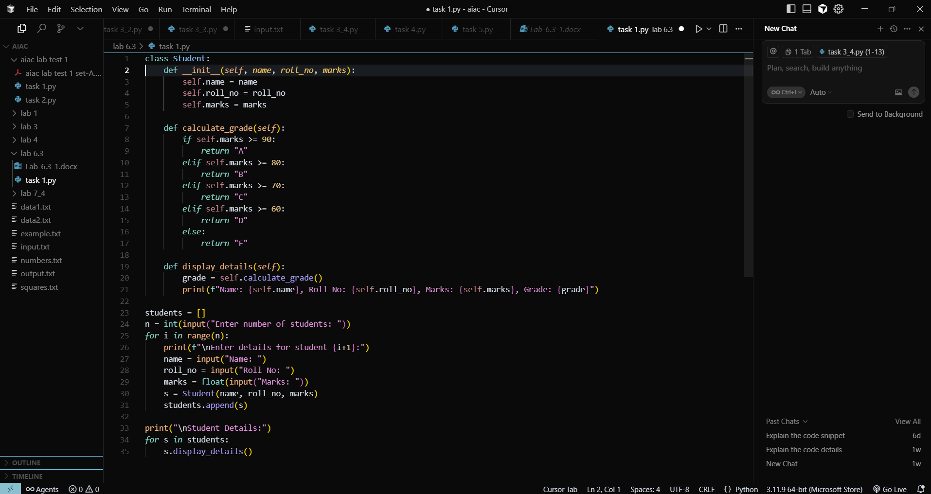  Output:  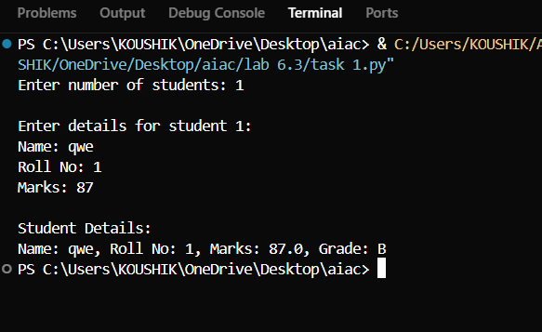  Code explanation:  This Python code implements a Student Management System using object-oriented programming with a Student class that stores student information (name, roll number, and marks) and includes methods for calculating grades based on marks (A for 90+, B for 80-89, C for 70-79, D for 60-69, F for below 60) and displaying complete student details. The main program first prompts the user to specify the number of students, then uses a for loop to collect information for each student (name, roll number, and marks) through user input, creates a Student object for each entry, and stores them in a list. Finally, it iterates through the student list and calls the display_details() method for each student to print their complete information including the calculated grade, demonstrating class instantiation, list manipulation, and method calling in a practical student grading application.  Expected Output#1  - Class with constructor and display_details() method  Task Description#2 (Loops)  - Prompt AI to complete a function that prints the first 10 multiples of a number using a loop.  - Analyze the generated code  - Ask AI to generate code using other controlled looping  Write code using For Loop, later complete code using While Loop  Code written without ai:  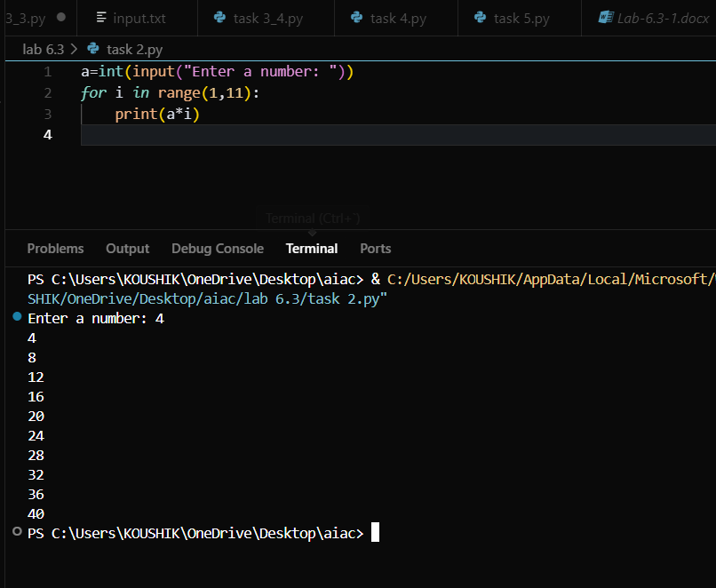  Completed code with ai:  Prompt:  improve the code by using while loop  Code:  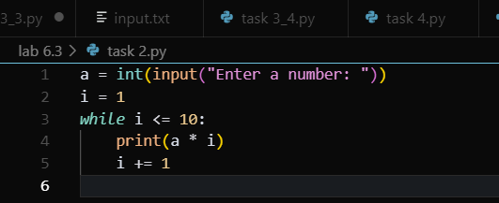  Output:  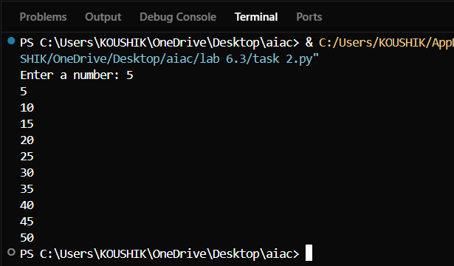  Code explanation:  This Python code creates a simple multiplication table generator that takes a user input number and displays its multiplication table from 1 to 10. The program first prompts the user to enter a number and converts it to an integer, then initializes a counter variable i to 1 and uses a while loop that continues as long as i is less than or equal to 10. Within the loop, it prints the product of the input number multiplied by the current value of i, then increments i by 1, effectively generating and displaying each row of the multiplication table (a×1, a×2, a×3, ..., a×10) where 'a' is the user's input number.  Expected Output#2  - Correct loop-based implementation  Task Description#3 (Conditional Statements)  - Ask AI to write nested if-elif-else conditionals to classify age groups.  - Analyze the generated code  - Ask AI to generate code using other conditional statements  - 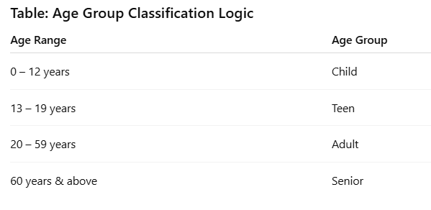  Code written without ai:  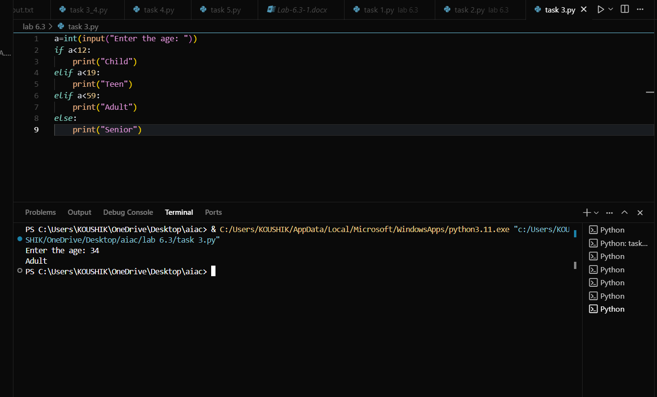  Completed code with ai:  Prompt:  improve the code by using other other conditional statements and write the error message for wrong input and print the output  Code:  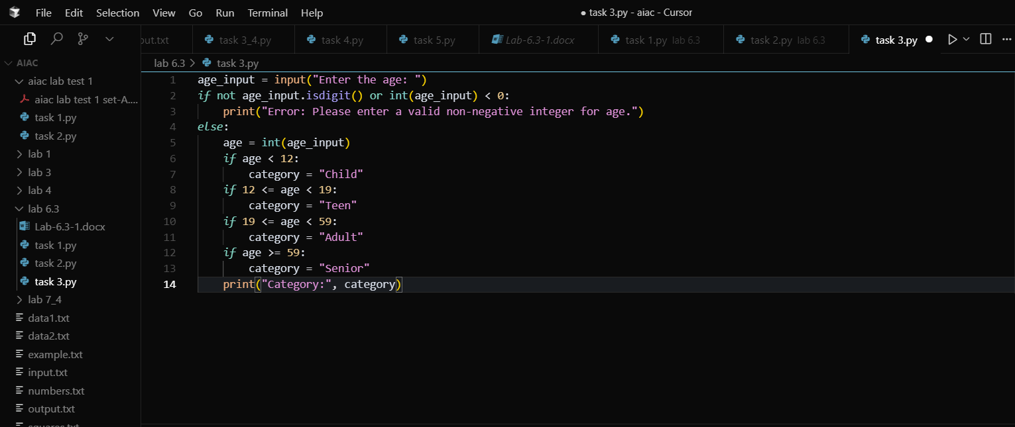  Output:  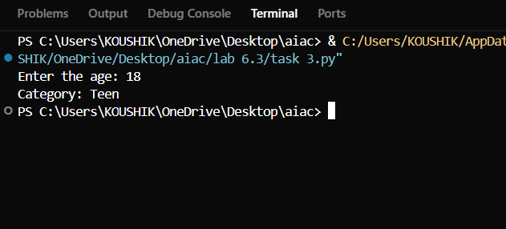  Code explanation:  This Python code creates an age categorization system that takes user input for age and classifies individuals into different life stage categories. The program first validates the input to ensure it's a valid non-negative integer using isdigit() and range checking, displaying an error message if the input is invalid. If the input is valid, it converts the string to an integer and uses a series of conditional statements to categorize the age into four groups: "Child" (under 12), "Teen" (12-18), "Adult" (19-58), and "Senior" (59 and above), then prints the determined category. The code demonstrates basic input validation, type conversion, and conditional logic for age-based classification.  Expected Output#3  - Age classification function with appropriate conditions and with explanation  Task Description#4 (For and While loops)  - Generate a sum_to_n() function to calculate sum of first n numbers  - Analyze the generated code  - Get suggestions from AI with other controlled looping  Code written without ai:  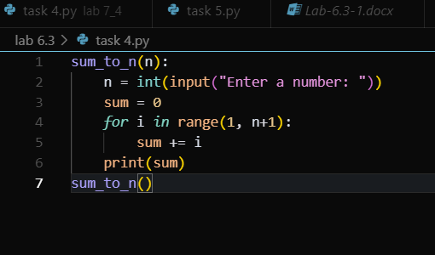  Completed code with ai:  Prompt:  fix the code with other controlled looping and print the output  Code:  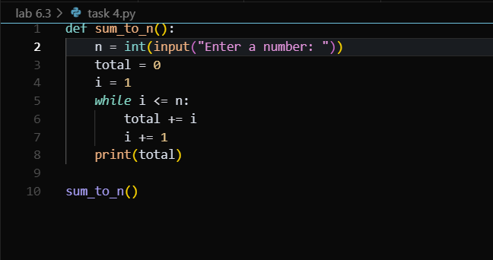  Output:  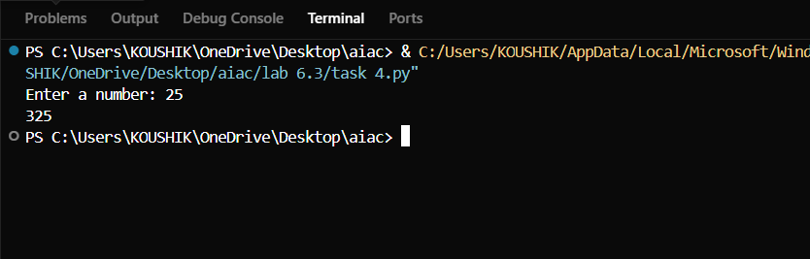  Code explanation:  This Python code defines a function sum_to_n() that calculates the sum of all integers from 1 to a user-specified number n. The function takes user input for the number n, initializes a total variable to 0 and a counter i to 1, then uses a while loop to iteratively add each number from 1 to n to the running total, incrementing the counter after each addition. Once the loop completes (when i exceeds n), it prints the final sum. The code demonstrates basic function definition, user input handling, loop control with a while statement, and accumulator pattern for summing a sequence of numbers, providing a simple implementation of the mathematical concept of summing consecutive integers.  Expected Output#4  - Python code with explanation  Task Description#5 (Class)  - Use AI to build a BankAccount class with deposit, withdraw, and balance methods.  - Analyze the generated code  - Add comments and explain code  Instructions  - Initialize BankAccount class with attributes like name, balance  - Method to deposit amount  - Method to withdraw amount  - Method to check balance  Code written without ai:  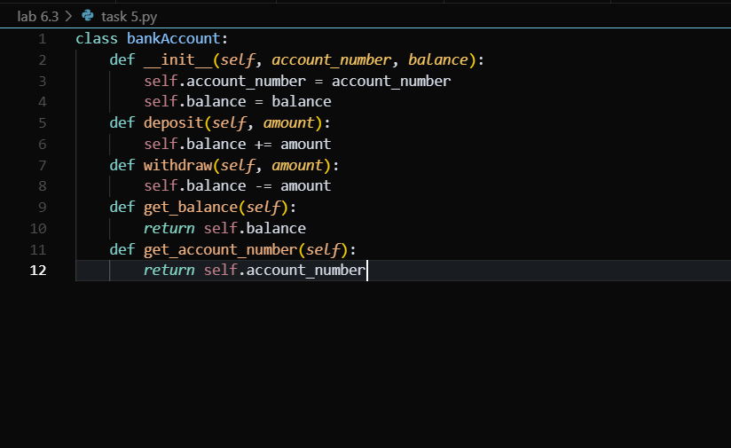  Completed code with ai:  Prompt:  improve the code by giving options for creating account ,deposit amount,withdraw amount,check balance. take them as input and print the output  Code:  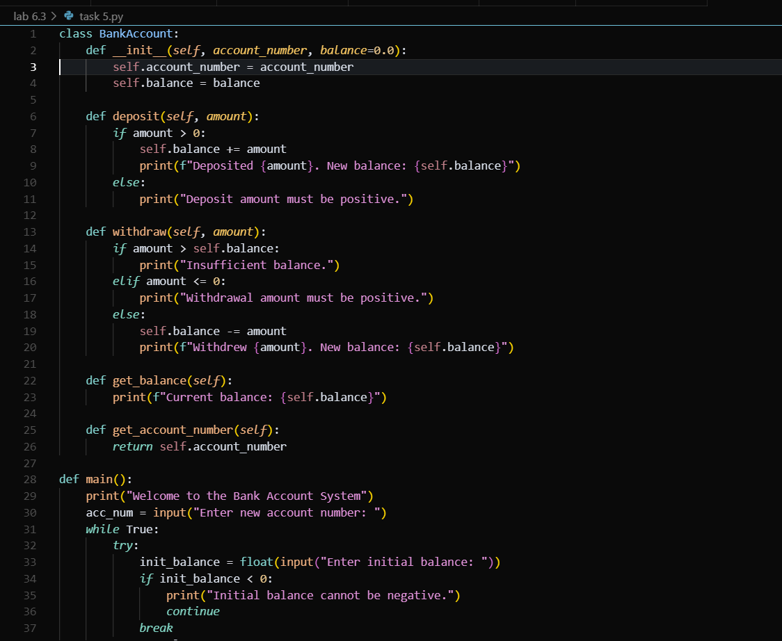  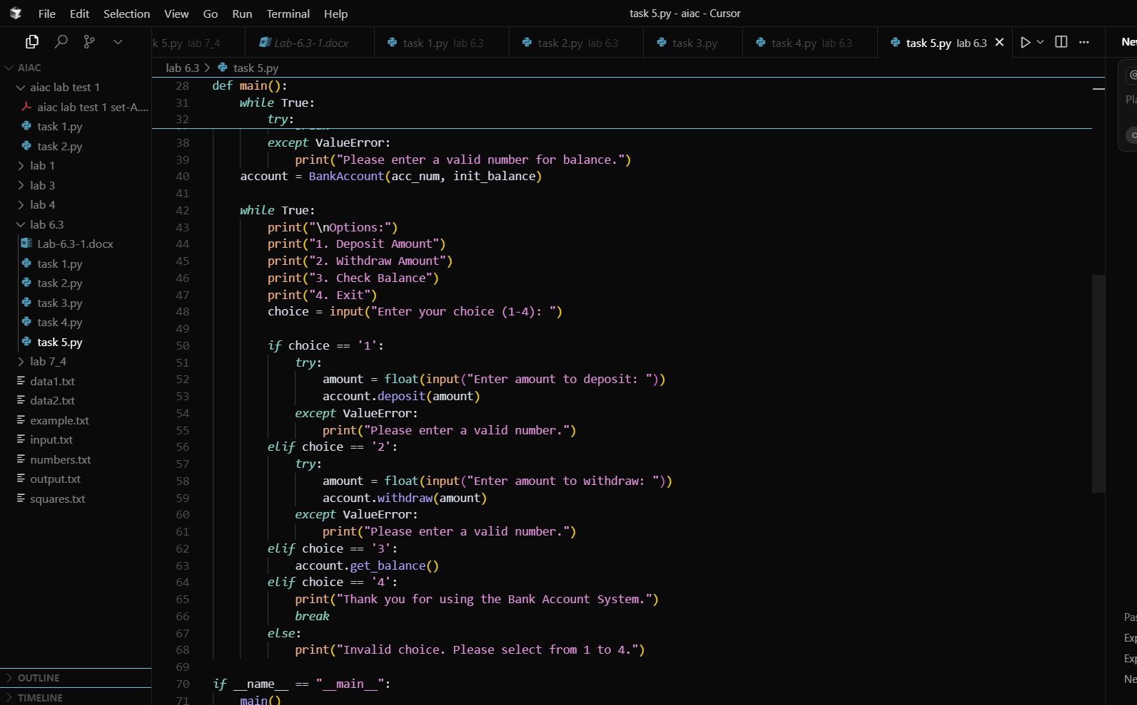  Output:  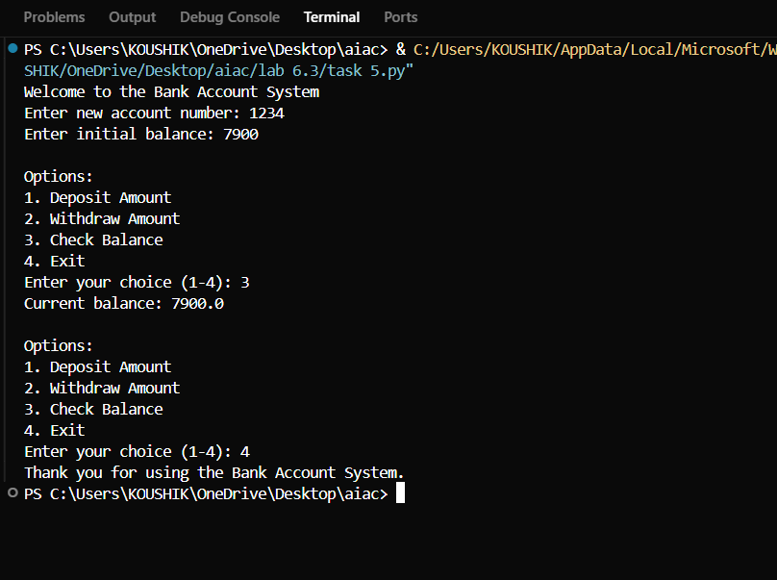  Code explanation:  This Python code implements a simple Bank Account Management System using object-oriented programming. The BankAccount class encapsulates banking functionality with methods for depositing, withdrawing, and checking balance, along with proper validation to ensure positive amounts and sufficient funds. The main() function creates an interactive console-based interface where users first create a new account by providing an account number and initial balance (with input validation), then access a menu-driven system offering four options: deposit money, withdraw money, check current balance, or exit the program. The code includes comprehensive error handling using try-catch blocks to manage invalid numeric inputs and provides user-friendly feedback messages for all banking operations, making it a complete demonstration of class design, user input validation, and interactive program flow.  Expected Output#5  - Python code with explanation  Note: Report should be submitted a word document for all tasks in a single document with prompts, comments & code explanation, and output and if required, screenshots  Evaluation Criteria:  Criteria Max Marks  Class 1.0  Loops 1.0  Conditional Statements 0.5  Total 2.5 Marks |  |  |  |  |  | Week3 - Wednesday

